**Ex. No.:1A**

**Date: 27/01/2024**

**CAESAR CIPHER**

**Aim:**

To write a Python program to encrypt and decrypt a Plain Text using Caesar Cipher.

**Algorithm:**

1. Enter the Plain Text given by the user.
2. Get the Secret key from the user.
3. If the character is uppercase take the ASCII value of it and add with key and subtract with original ASCII value modules with total number of characters.
4. If it is lowercase alphabet take its ASCII value and do necessary operation modules with total.
5. For digit and special characters take it’s ASCII value and process it in its string.
6. Point the encrypted text.
7. Subtract the key from the encrypted one to get the original text.

**Program:**

**#Caesar Cipher**

p = input("Enter Plain Text:")

k = int(input("Enter Select Key:"))

c = ""

for i in range(len(p)):

if p[i].isupper():

c += chr((ord(p[i])+k-65) % 26 + 65)

elif p[i].islower():

c += chr((ord(p[i])+k-97) % 26 + 97)

elif p[i].isdigit():

c += chr((ord(p[i])+k-48) % 10 + 48)

elif p[i] == ':' or p[i] == ';' or p[i] == '<' or p[i] == '=' or p[i] == '>' or p[i] == '?' or p[i] == '@':

c += chr((ord(p[i])+k-58) % 7 + 58)

elif p[i] == '[' or p[i] == '\\' or p[i] == ']' or p[i] == '^' or p[i] == '_' or p[i] == '`':

c += chr((ord(p[i])+k-91) % 6 + 91)

elif p[i] == '{' or p[i] == '|' or p[i] == '}' or p[i] == '~':

c += chr((ord(p[i])+k-123) % 4 + 123)

else:

c += chr((ord(p[i])+k-32) % 16 + 32)

print("The encrypted message is", c)

d = ""

for i in range(len(c)):

if c[i].isupper():

d += chr((ord(c[i])-k-65) % 26 + 65)

elif c[i].islower():

d += chr((ord(c[i])-k-97) % 26 + 97)

elif c[i].isdigit():

d += chr((ord(c[i])-k-48) % 10 + 48)

elif c[i] == ':' or c[i] == ';' or c[i] == '<' or c[i] == '=' or c[i] == '>' or c[i] == '?' or c[i] == '@':

d += chr((ord(c[i])-k-58) % 7 + 58)

elif c[i] == '[' or c[i] == '\\' or c[i] == ']' or c[i] == '^' or c[i] == '_' or c[i] == '`':

d += chr((ord(c[i])-k-91) % 6 + 91)

elif c[i] == '{' or c[i] == '|' or c[i] == '}' or c[i] == '~':

d += chr((ord(c[i])-k-123) % 4 + 123)

else:

d += chr((ord(c[i])-k-32) % 16 + 32)

print("The decrypted message is", d)

**Output:**

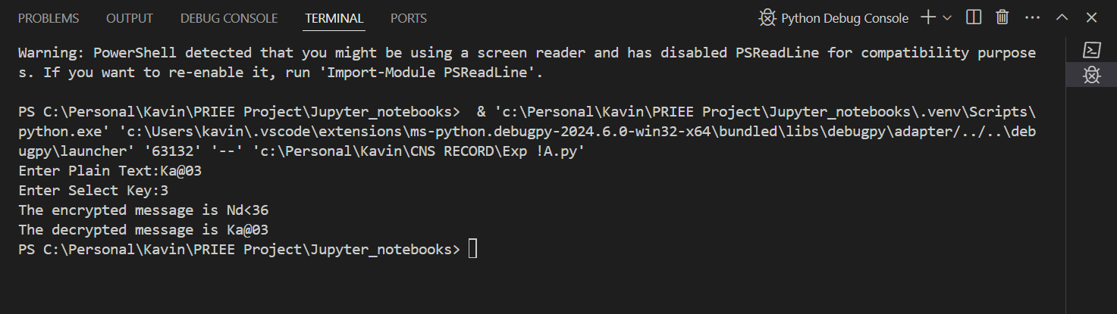

**Result:**

Hence, the Caesar Cipher program has been implemented successfully.